Online Picture Management
Objective:
Online Picture Management is an online application to be built as a A social-networking website that is to share Photos.
Users of the System:
- Admin
- User
Functional Requirements:
- Should provide a common platform where people can Share photos.
- Should provide for automatic tagging of pictures and categorise them.
- Should have the ability to tag social discipline violators using their UID
- Authenticity for adding users is utmost important for such a website.
- Definitely one should not be allowed to have more than one profile, validation of user should be done using email id.

While the above ones are the basic functional features expected, the below ones can be nice to have add-on features:
- There are lot of freeware & open source applications available for many social functions. The team is expected to search & leverage these to the maximum.
- Multi-factor authentication for the sign-in process

Output/ Post Condition:
- Reports for users
- Reports for Site admin..the operational reports to make the site better in future

Non-Functional Requirements:

Security | - App Platform –UserName/Password-Based Credentials  - Sensitive data has to be categorized and stored in a secure manner  - Secure connection for transmission of any data
Performance | - Peak Load Performance  - Online Picture Management-< 3 Sec  - Admin application < 2 Sec  - Non Peak Load Performance
Availability | - 99.99 % Availability
Standard Features | - Scalability  - Maintainability  - Usability  - Availability  - Failover
Logging & Auditing | - The system should support logging(app/web/DB) & auditing at all levels
Monitoring | - Should be able to monitor via as-is enterprise monitoring tools
Cloud | - The Solution should be made Cloud-ready and should have a minimum impact when moving away to Cloud infrastructure
Browser Compatible | - IE 7+  - Mozilla Firefox Latest – 15  - Google Chrome Latest – 20  - Mobile Ready

Technology Stack
Front End | React 16+  Google Material Design  Bootstrap / Bulma
Server Side | Spring Boot  Spring Web (Rest Controller)  Spring Security  Spring AOP  Spring Hibernate
Core Platform | OpenJDK 11
Database | MySQL or H2

Platform Pre-requisites (Do’s and Don’ts):
- The React app should run in port 8081.
- Spring boot app should run in port 8080.

Key points to remember:
- The id (for frontend) and attributes(backend) mentioned in the SRS should not be modified at any cost. Failing to do may fail test cases.
- Remember to check the screenshots provided with the SRS. Strictly adhere to id mapping and attribute mapping. Failing to do may fail test cases.
- Strictly adhere to the proper project scaffolding (Folder structure), coding conventions, method definitions and return types.
- Adhere strictly to the endpoints given below.

Application assumptions:
- The login page should be the first page rendered when the application loads.
- Manual routing should be restricted by using AuthGaurd by implementing the canActivate interface. For example, if the user enters as http://localhost:4200/signup or http://localhost:4200/home the page should not navigate to the corresponding page instead it should redirect to the login page.
- Unless logged into the system, the user cannot navigate to any other pages.
- Logging out must again redirect to the login page.
- To navigate to the admin side, you can store a user type as admin in the database with a username and password as admin.
- Use admin/admin as the username and password to navigate to the admin dashboard.

Validations:
- Basic email validation should be performed.
- Basic mobile validation should be performed.
Project Tasks:
API Endpoints:
USER
Action | URL | Method | Response
Login | /login | POST | true/false
Signup | /signup | POST | true/false
Get All image – Home | /image | GET | Array of image
Add Comment | /image/{id} | POST | Comment added to Image
Get Image By Id | /image/{id} | GET | Image Details
Delete Comment | /comment/delete | DELETE | Comment Deleted
Update Comment | /comment/update/{id} | PUT | Comment Updated
ADMIN
Action | URL | Method | Response
Get All User | /admin | GET | Array of Users
Add User | /admin/add User | POST | User added
Delete User | /admin/delete/{id} | DELETE | User deleted
User Edit | /admin/userEdit/{id} | PUT | Save the Changes
Get All Image | /admin/image | GET | Array of Images
Delete Image | /admin/image/{id} | DELETE | Image deleted
Image Edit | /admin/imageEdit/{id} | PUT | Save the Changes
Get All Comment | /admin/comment | GET | Array of Comments

Frontend:
User:
Login:
Output Screenshot:
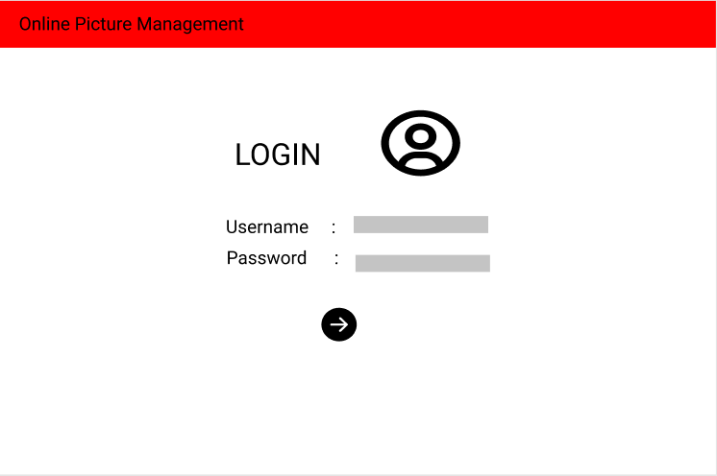

Signup:
Output Screenshot:
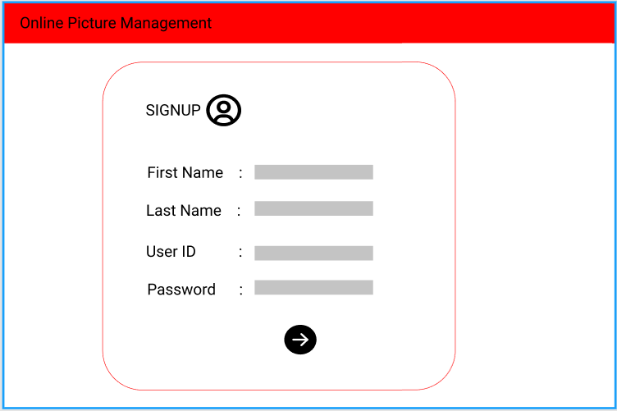
Home:
Output Screenshot:
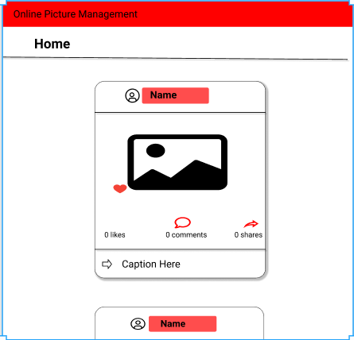

Profile:
Output Screenshot:
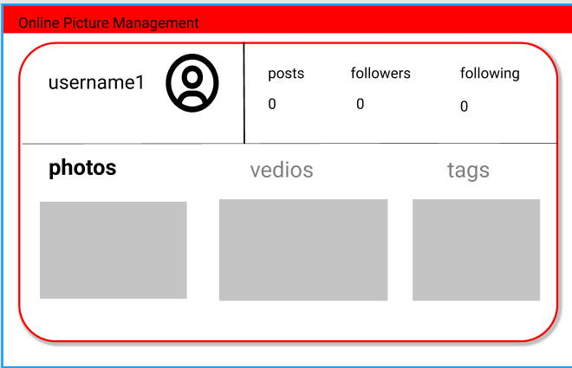
Comments:
Output Screenshot:
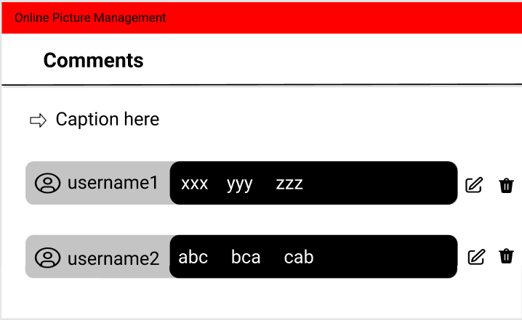

Admin:
Home:
Output Screenshot:
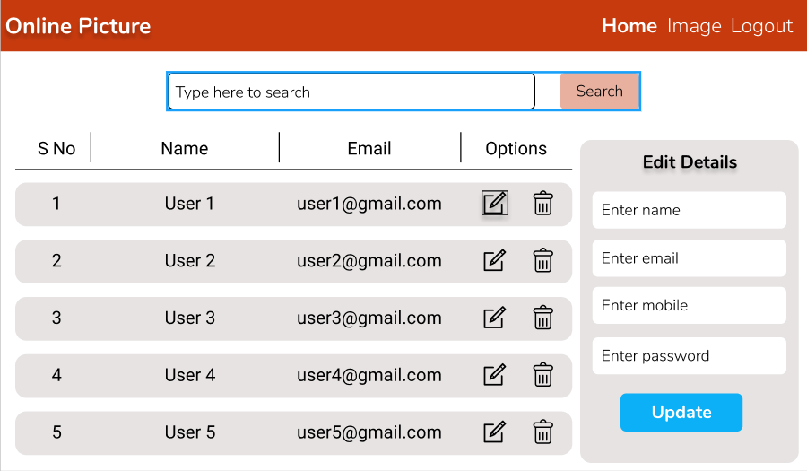
Backend:
Class and Method description:

Model Layer:

- UserModel: This class stores the user type (admin or user) and all user information.
  - Attributes:
    - email: String
    - password: String
    - username: String
    - mobileNumber: String
    - active: Boolean
    - role: String
  - Methods: -

- LoginModel: This class contains the email and password of the user.
  - Attributes:
    - email: String
    - password: String
  - Methods: -
- ImageModel: This class stores the details of the product.
  - Attributes:
    - imageId: String
    - imageName: String
    - image: Blob
    - imageTag: String
    - comments: CommentModel
  - Methods: -
- CommentModel: This class stores the cart items.
  - Attributes:
    - commentId: String
    - Comment: String
    - userId: UserModel
  - Methods: -
Controller Layer:
- SignupController: This class control the user signup
  - Attributes: -
  - Methods:
    - saveUser(UserModel user): This method helps to store users in the database and return true or false based on the database transaction.
- LoginController: This class controls the user login.
  - Attributes: -
  - Methods:
    - checkUser(LoginModel data): This method helps the user to sign up for the application and must return true or false
- UserController: This class controls the add/edit/update/view User.
  - Attributes: -
  - Methods:
    - List<UserModel> getUser(): This method helps the admin to fetch all User from the database.
    - List< UserModel > getOnlineUser(): This method helps to retrieve all the online user from the database.
    - UserModel userEditData(String id): This method helps to retrieve a user from the database based on the user id.
    - userEditSave(UserModel data): This method helps to edit a user and save it to the database.
    - userDelete (String id): This method helps to delete a user from the database.
- ImageController: This class helps in adding product to the cart, deleting the Image from the cart, updating items in the cart.
  - Attributes: -
  - Methods:
    - addImage(Blob image): This method helps the user to add the image to the database.
    - ImageModel showImage(String id): This method helps to view the image.
    - deleteImage(String id): This method helps to delete a image from the database.
    - updateImage(String id): This method helps to update a image from the database.
- CommentController: This class helps in adding, deleting, updating the comment.
  - Attributes: -
  - Methods:
    - addComment(String Id): This method helps the user to add the Comment to the database.
    - deleteComment(String id): This method helps to delete a Comment from the database.
    - updateComment(String id): This method helps to update a Comment from the database.

